Install Manual for Dodge

Disclaimer: Note before installation, we recommend you speak with the dealership, as installation of this lift may void your trucks factory warranty. It is the purchaser’s responsibility to verify their trucks factory warranty, NOT Lift & Tow LLC.

WHAT DOES THIS WARRANTY COVER?

This warranty covers defects in parts & workmanship under INTENDED USE for the warranty period. The INTENDED USE of a unit for this warranty is the vertical lift, at most, of 4000 pounds. The towing weight maximum capacity is 8000 pounds. NOT crossing the provided safety chains voids the warranty under INTENDED USE. INTENDED USE for a unit also requires scheduled weekly lubrication of ALL grease fittings, along with the top, bottom, & sides of the mid & small boom sections. Depending on the frequency of use, weekly lubrication could be enough to assure warranty coverage in most environments. NOT having a lubrication scheduled weekly is visibly obvious and WILL automatically void this warranty. This could also go as far as pins becoming seized, forcing the unit to break upon pressure with lack of movement being able to function properly. Lift & Tow LLC will determine whether a part of a unit is deemed defective by video, picture, or an in-person inspection taken place for further assessment. Any part of a unit that is under warranty and deemed defective, will be provided free of charge, including shipping and/or labor depending on the circumstances. At the discretion of Lift & Tow LLC, the customer will be required to transport their truck to Lift & Tow LLC shop for warranty repairs. The purchaser of a unit will not assume that Lift & Tow LLC will drive to where the truck is to repair/troubleshoot the issue. Along with not assuming Lift & Tow LLC will pay labor costs to other parties for the unit’s repair if the quotes are not reasonable, or solely work regarding the lift directly. Lift & Tow LLC recognizes that our units are shipped worldwide, making it difficult or too costly for the truck to be shipped to Lift & Tow LLC shop for repairs. It is the goal of Lift & Tow LLC to meet the repair and maintenance needs to our customers. Lift & Tow LLC commits to supporting its customers through providing parts & information, fully recognizing that its distant customers NEED TO PLAN on having their own resources to do critical repairs.

HOW LONG DOES THE COVERAGE LAST?

Our units are covered with a 2-year warranty on fabrications from the purchase date. The units also come with a 1-year warranty on the pump, cylinders, valves, & remote controls from the purchase date.

WHAT DOES THIS WARRANTY NOT COVER?

Lift & Tow LLC will not cover damage by collision, or any condition identified as unintended use. It is your responsibility to lubricate & maintain the unit properly, & weekly. Our warranty is NOT transferable for any post installation sales.

THE BOX:
1. Pump with Fittings
2. Valve Block & Mounting Bracket
3. 2 Ratchets & 2 Straps
4. Fuse/Holder with 6” Black Wire
5. 22” Pump Ground Wire
6. 15’ Power Wire
7. Remote (Wired/Wireless)
8. 12’ P & T Hoses
9. 94” Open & 92” Close Hose
10. 30” In & Out Hose
11. 20” Up & 17” Down Hose
12. Upper Shock Mount
13. Lower Shock Mount
14. Bag of Hardware

RECOMMENDED TOOLS:

1. Assorted Wrench/ Socket Set
2. Pry Bars
3. Hammer
4. Punch
5. Side Cutters
6. Transmission Jack (or similar)
7. Cutting Torch
8. Welder (please note welding is mandatory when installing the lift)
Install Instructions

1. Disconnect truck battery/ batteries.
2. Raise the truck on lift/jacks.
3. Remove rear wheels if on jacks, not needed if using a drive on lift.
4. Remove spare tire, along with tire winch & heat shield.
5. Remove 3 bumper bolts from each side.
6. Remove driver side rear shock.
7. Measure & cut crossmembers.
8. Cut factory hitch receiver.
9. When prepping the mainframe to go under the truck, install the valve block bracket, upper shock mount, and set the mounting pads into correct placement on the 4 end tubes of the mainframe.
10. Stretch the mainframe apart by the sliders, to roughly 30” measuring by the outside on the front/back of the frame.
11. Raise the mainframe up into under the truck, roughly 3” from the rear differential to the back of the mainframe & tightly mount the mounting pads to the OUTSIDE of the trucks frame.
12. With what little play is left, pull apart/adjust the mainframe on more time to verify the frame is square, and still sitting at 30”.
13. Weld both sides & bottom of the mounting bracket tube tight to the mainframe.
14. Bolt driver side shock to upper shock mount.
15. Install lower shock mount ensuring proper angle on shock.
16. Weld upper and/or lower shock mount.
17. Adjust upper shock mount side to side, as needed to get proper angle. Weld upper shock mount.
18. Tighten bolts to the upper shock & lower shock.
19. Install your wireless remote transmitter above your mainframe. Use the bolt connected to the bottom of the transmitter, place through the bracket on the top of the mainframe. This bracket will be located on the rear passenger side of the truck. Once the bolt is placed through the bracket, secure with a washer & nut.
20. Mount valve block to bracket using the two bolts on the bottom to secure to the bracket. Make sure the side marked P & T are facing the front of the truck, which will make the side marked, open, close, in, out, up, & down face towards the rear driver side.
21. Connect marked hoses accordingly to the valve block.
22. Raise three boom sections into place, aligning the main section bushing with the mainframe bushings.
23. Connect the marked in & out hoses accordingly to the in and out cylinder coming out the back of the main section.
24. Take your 1 ½” main pin, coat with anti-seize. Insert the main pin through the mainframe, into the main section bushing and back out through the mainframe. Secure the pin with a cotter pin. Connect Tie rod Cylinder.
25. Raise the Z Bar up to the booms small section, align headplates with hole for the 2 ½” pin. Insert 2 ½” pin, & secure with nut on the bottom. Do not tighten yet.
a. Use custom Z Bar Nut Socket if purchased.
26. Extend the boom the entire way out, run open & close hoses alongside the boom & through the hose clamps on top of the main section, then on the side of the mid-section. Do not tighten yet.
27. Hook up the open and close hoses to the Z Bar cylinders.
28. Turn Z Bar completely towards the passenger side of the truck, tighten hose clamps with adequate amount of slack in hoses.
29. Straighten Z Bar then tighten nut on 2 ½” pin fully.
30. Install grease fittings in main section lower bushing.
31. Grease all 12 grease fittings, along with the top, bottom, & sides of the mid & small boom section.
a. 2 grease fittings on the bottom of the mainframe, 1 grease fitting on the mid boom section, 1 grease fitting on the top main section, 1 grease fitting on the lower main bushing, 7 grease fittings on the Z Bar.
b. You can refer to our grease tutorial on Instagram @lift_and_tow or our website at www.liftandtow.com

ELECTRICAL & HOSES

- Disconnect vehicle batteries.
- Drill two 3/8” holes 3 1/4” apart in the bed of truck where pump is going to be installed. This usually is the front right section of the bed.
  - Make sure your holes are 4” back from the front of the bed to avoid the beds front crossmember.
- Use 2” hole saw to drill the hole for the PVC adapter.
  - This is what the hoses and wires are going to run through.
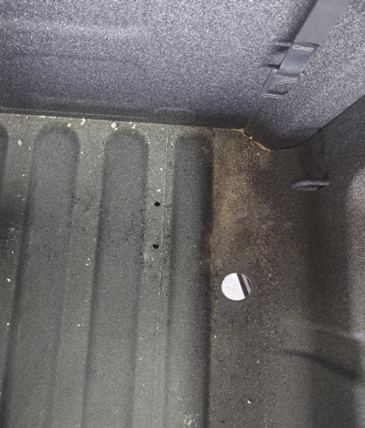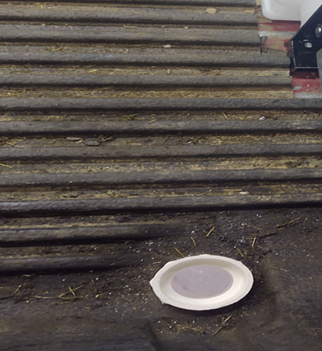

- Insert the PVC, as shown in the picture above, this is found in the bag of hardware. Place this in the hole made, and tighten the nut underneath the bed.
- Screw the two “all threads” into the outer holes at the bottom of the pump. Set the pump in the two drilled holes in the bed.
  - This is shown in the pictures below.

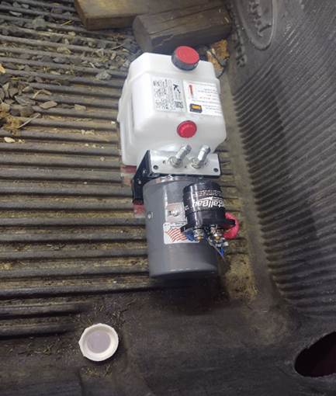
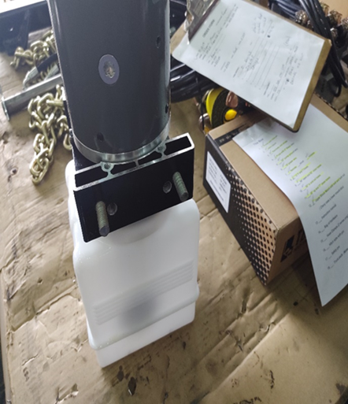

- Put the washers and nuts on the all thread and tighten with a 9/16” socket or wrench.
  - This is shown below
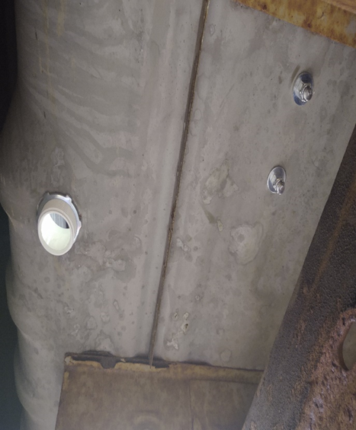

- Run the power wire up through the PVC adapter to rear 3/8” lug on the solenoid. Leave the flat washer on the solenoid, put on the power wire, lock washer, then finally the nut. ****ONLY FINGER TIGHTEN****
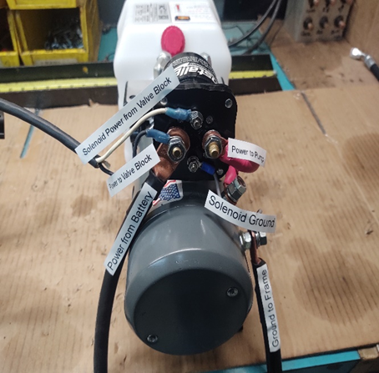

- Run the power cable from the bed, going up under the cab and securing to the cab crossmembers using P clamps and self-tapping screws. Self-tapping screws have a 5/16" head.
  - Refer to the picture below.
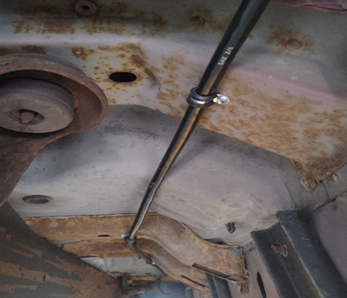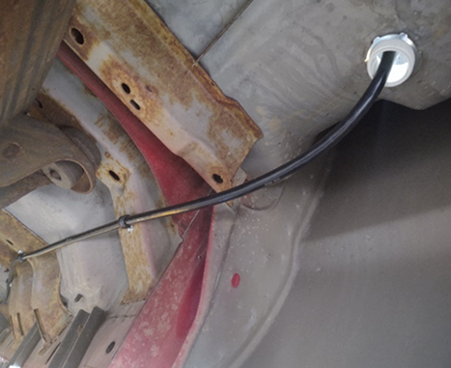

- Push the wire up into the engine compartment and pull the excess wire up.
- Connect the fuse to the power wire. Tighten the nuts on the fuse block for the power wire and the small jumper. Use a 9/16” wrench.
  - Refer to the picture below.
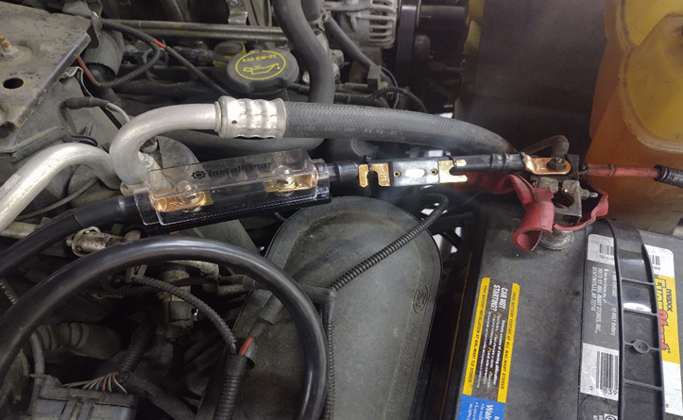
- Connect the small jumper to the battery’s positive terminal.
  - Leave the batteries disconnected.
- Drill a hole in the frame under bed close to PVC adapter 3/8" to bolt ground wire through. Use bolt, washers, and nut (BOH) to secure ground to frame. The ground wire has two different lug sizes. The smaller hole lug attaches to the lug on the front side of the pump. The larger whole lug is secured to the frame.
  - Refer to picture below
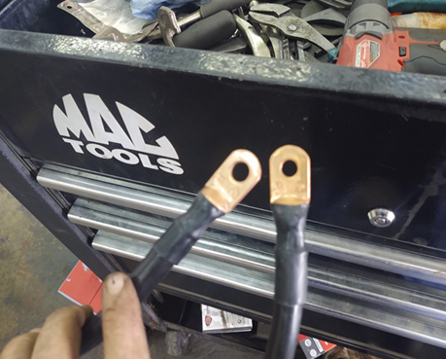

- The front lug on the front side of the motor with a small wire coming from solenoid, where the ground wire attaches to. Tighten nut with 1/2" wrench.
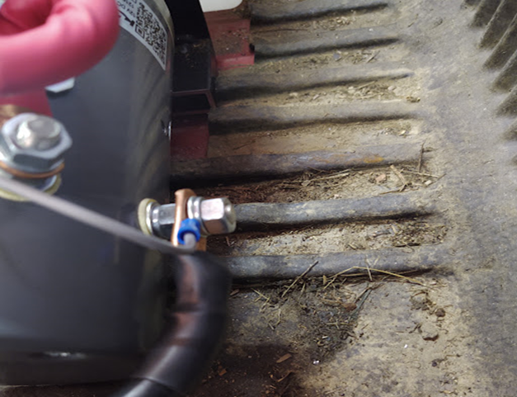
  - Refer to picture below

- Run the “P” and “T” hoses from valve block to PVC adapter in bed to the pump. Run wire from valve block to the pump. Use P clamps and self-tapping screws to secure hoses to bed crossmembers. Use zip ties to secure wire to hoses. Make sure hoses and wire are as far away from exhaust as possible.
  - Refer to picture below

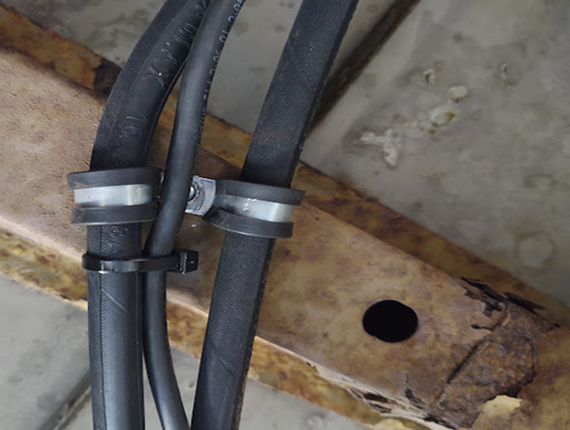

- Valve block, hoses, and pump are marked with P and T.
- Adjust fittings on pump to point in proper direction and then tighten lock nut on fittings. Use 11/16" wrench.
- Tighten hose fittings at pump and valve block. Use 11/16" and 9/16" wrenches at pump and two 9/16" wrenches at valve block.
- Take off nut and lock washer for power wire at solenoid and put black wire with large eyelet on lug. Then reinstall lock washer and nut. Tighten with 9/16" wrench.
  - DO NOT OVER TIGHTEN NUT & STRIP THREADS
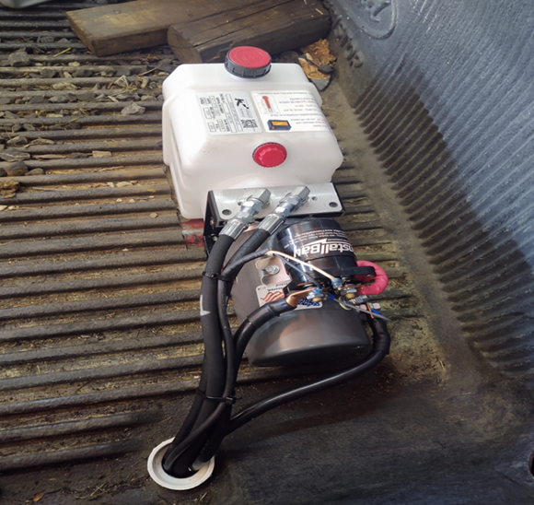

- Put white wire with small eyelet on top small lug on solenoid and tighten. Use 5/16" wrench.
- Zip tie access hoses and wire underneath bed.
- Fill reservoir with ATF. ONLY USE ATF FLUID FOR THIS UNIT (ATF-G3). IF YOU USE HYDRAULIC FLUID, YOU WILL VOID YOUR WARRANTY ON THE PUMP.
- Reconnect batteries.

