FRAME REINFORCEMENT MANUAL
Step One: Cut all green lines as seen in pictures below, Notch spring hangers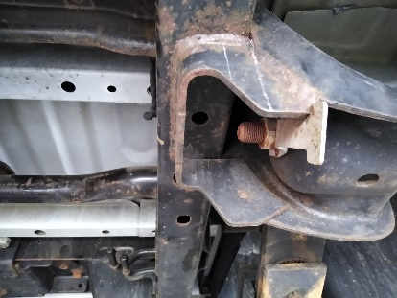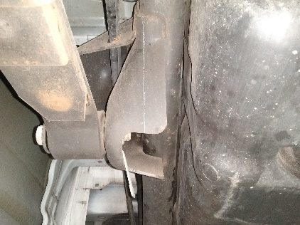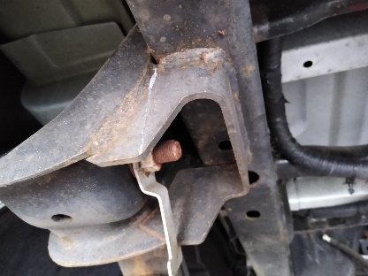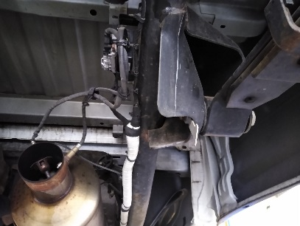
Step Two: Remove spring hangers and grind all welds down.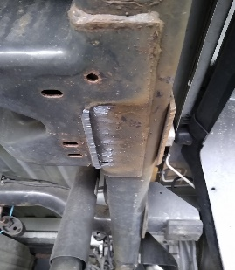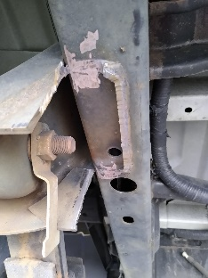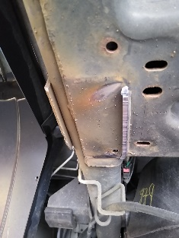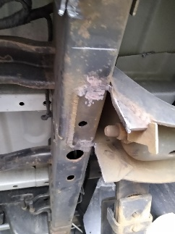 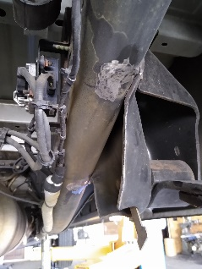
Step Three: Remove Park brake cable hanger from driver side
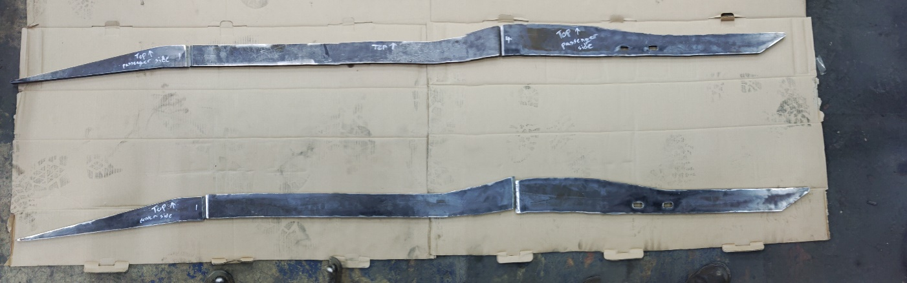
Step Four: Start at the bumper and measure 8 inches back on the frame, that will be where you place the reinforcement plate.
Step Five: Weld on the reinforcement plates to the frame of the truck.
Step Six: Weld the spring hangers to the reinforcement plates you welded onto the frame.
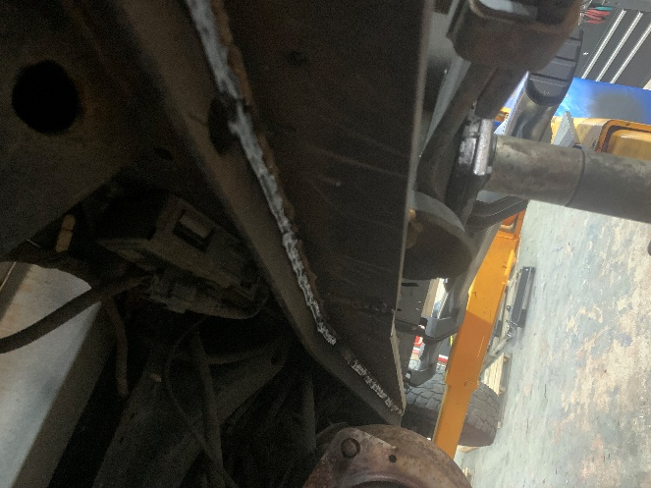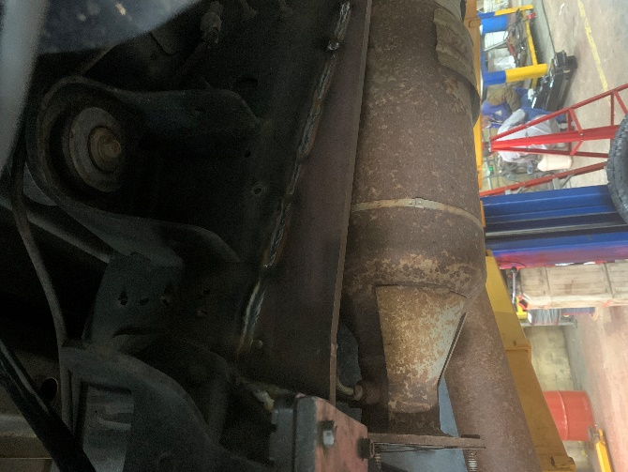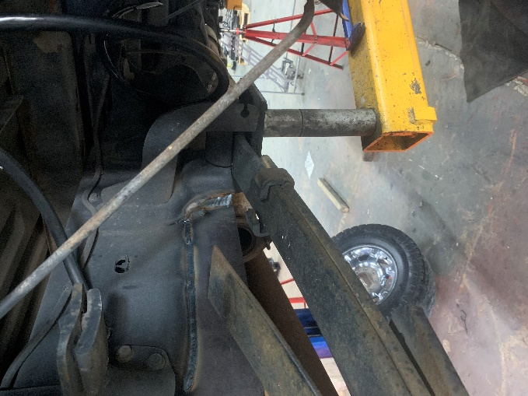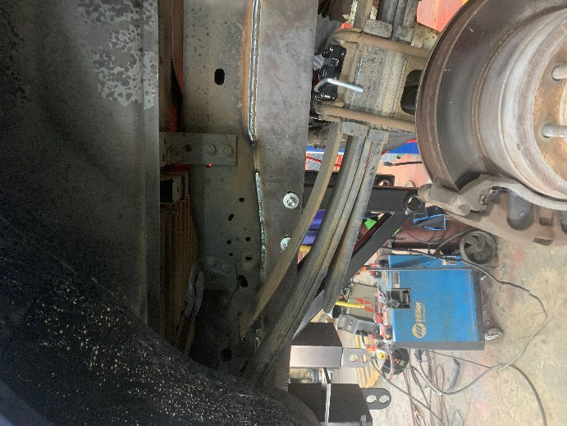
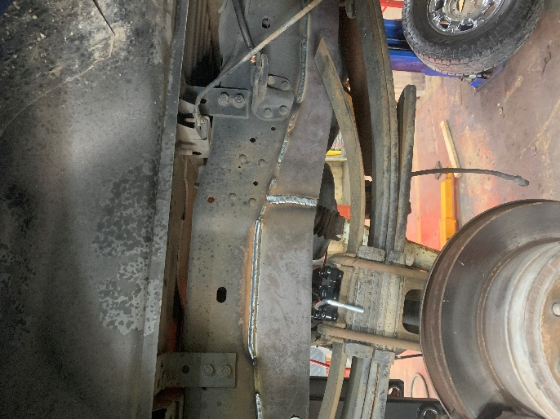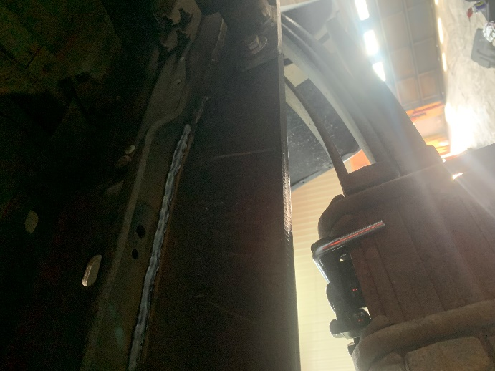
***Tip: When welding the frame reinforcement onto the frame follow the outside edge***
***Tip: Use a heat shield up against the fuel tank when welding near***

