Lift & Tow 4000 lb. Dollies
Owner & Maintenance Manual
Product Overview
Thank you for purchasing the Lift & Tow 4000 lb. Dollies. This manual provides an overview of the components included with your purchase and outlines required maintenance procedures to ensure safe operation and long service life.
Included Components
Reference Images and Diagrams are provided below to clearly identify what is included with your Lift & Tow 4000 lb. Dollies purchase. These visuals are intended to match the components listed in this section and the official parts list.

Figure 1: Lift & Tow 4000 lb. Dolly – Complete Assembly Overview
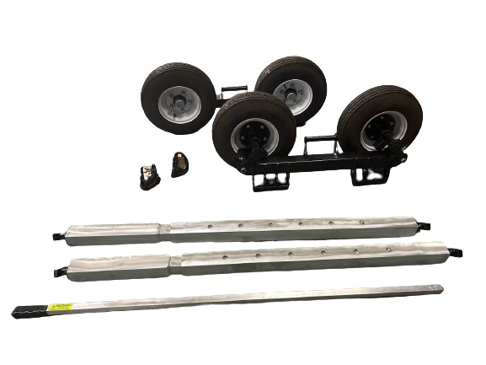
Dolly Cross Bars
Dolly Break Over Bar
Dolly Ratchet & Straps
Dolly Mainframe Complete With 5.70 x 8 LRD Tires
Figure 1 represents the complete contents of your purchase.
- Dolly Mainframes (2)
- 5.70 x 8 LRD Dolly Tires (4 total, pre-installed)
- Dolly Crossbars (2 complete assemblies)
- Ratchet & Strap Sets (2)
- Break-Over Bar (1)

All fabricated components are powder-coated black for corrosion resistance and durability.

Maintenance Schedule
Routine maintenance should be performed every 10–20 tows. There is a complete total of 8 grease fittings per dolly set. 4 grease fittings per dolly mainframe. 2 grease fittings on each side. For the cam lock grease fittings do not use more than one pump of grease. Grease the cam locks in the unlocked position as shown below
Spindle Pivot Grease Fitting
Cam Lock Grease Fitting
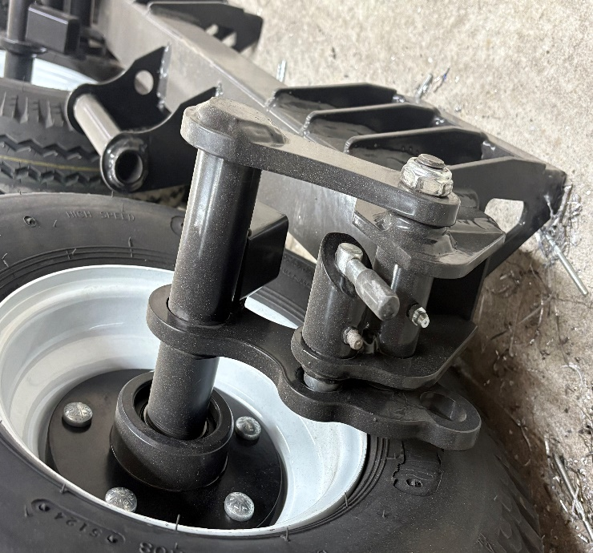

Required Maintenance Checks
During each maintenance interval, ensure the following:
- Wheel Lug Nuts: Torque all lug nuts to 70 ft-lbs.
- Spindle Pivot Bolt: Torque to 70 ft-lbs.
- Hub Inspection: Inspect bearings, spindle nut, and hub cap for wear, damage, or looseness.
Key Maintenance Torque Specifications
Component Torque Specification
Wheel Lug Nuts 70 ft-lbs.
Spindle Shoulder Nut 70 ft-lbs.
Spindle Nut 100 ft-lbs.

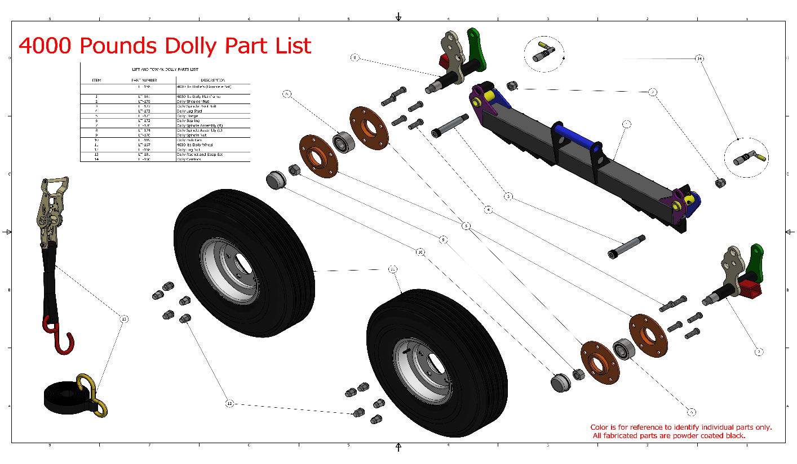
Figure 2: Lift & Tow 4000 lb. Dolly – Parts Identification Diagram
Figure 2 corresponds directly to the Lift & Tow 4000 lb. Dolly Parts List and is referenced throughout this manual for maintenance and service procedures. A downloadable PDF version of figure 2 is available on our website under the replacement parts tab.

Hub Assembly (Circled in Red):

- Dolly Lug Studs (5)
- Dolly Flanges (4)
- Dolly Bearing (2)

Refer to Figure 2 (Parts Identification Diagram) for visual identification of the hub assembly components. If new dolly bearings are purchased and need installed:

- Remove dolly hub cap, & lug nuts.
- Remove dolly tire.
- Remove dolly spindle nut.
- Take off the complete hub assembly.
- Remove the 5 lug studs from the hub assembly.
- Replace the bearing inside the hub with new bearing.
- Reassemble the hub assembly with lug studs & press them together until tight.
- Put hub assembly back on to the spindle and torque the spindle nut 100ft-lbs.
- Put dolly tire back on to lug studs & torque to 70ft-lbs.
- Put back on dolly hub cap.

After installation, rotate the wheel to confirm smooth operation and recheck torque after initial use.

Safety Notice
Failure to follow recommended torque specifications and maintenance intervals may result in equipment damage, reduced performance, or personal injury. Always perform inspections before towing and discontinue use if any component appears damaged or loose.

For replacement parts or additional support, please reference the Lift & Tow 4000 lb. Dolly Parts List. Followed by contacting Lift & Tow or an authorized distributor for Lift & Tow.

